
STANFORD TAEKWONDO

SPRING OPEN 2005
May 29-30
Burnham Pavilion, Stanford University
∗Adults and children, all levels
∗ Gyroogi (sparring) competition
∗ Poomsae (forms) competition
∗ Matted rings
∗ Match numbering system
∗ Electronic scoring system
∗ Consolation round

Spectator Admission
∗FREE∗ Stanford ID
$3 – Other students
$5 – General public
∗FREE∗ children under 5

Competitors
$50 – One or two events
$40 – Online registration

ONLINE REGISTRATION:
http://tkd.stanford.edu/spropen2005
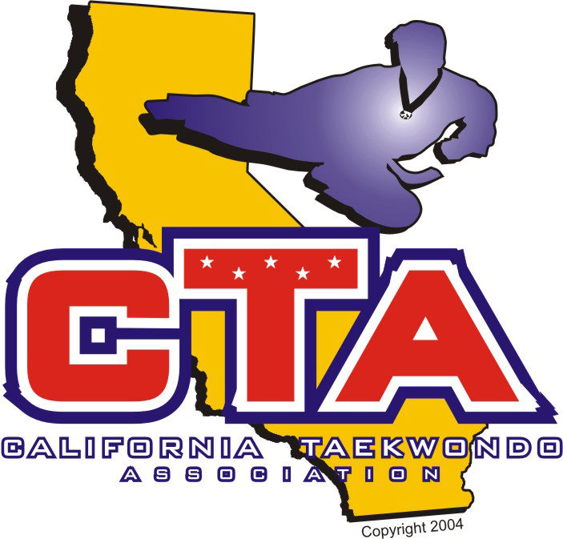

For more information:
stanfordtkd@yahoo.com
(650) 482-9727

